*COMPUTER SCIENCE INVESTIGATORY PROJECT*

***HOTEL MANAGEMENT SYSTEM***

PROJECT SUBMITTED BY:-

NAME=

CLASS/SEC=

ROLL NO.=

BOARD ROLL NO.=

ATOMIC ENERGY CENTRAL SCHOOL-4

# **ACKNOWLEDGEMENT**

*A heartfelt gratitude to those who have played*

*inspirational role in successful completion of this*

*Investigatory Project.*

*First, we are grateful to our Principal Shri* ***CHINMOY BASU****, next our Computer Science teacher Smt.* ***RANI SASTRY*** *who have guided us to complete this project successfully.*

*I am deeply indebted to them for their valuable*

*suggestions and unconditional support.*

*We are also thankful to our parents and our friends who have helped us at various stages of this project.*



**ATOMIC ENERGY CENTRAL**

**SCHOOL NO-4, ANUSHAKTINAGAR, MUMBAI**

**CERTIFICATE**

This is to certify that _______________of class

Board Roll No. __________of 2020-21 batch of

this school have successfully completed this

Investigatory project in Computer under the guidance of Smt. RANI SASTRY, (Computer teacher) in partial fulfilment of Computer Science Board Practical examination conducted by AECS-4, AnushaktiNagar, Mumbai-400094.

__________________

(Signature of Subject Teacher)

____________________

(Signature of Internal Examiner)

____________________

(Signature of External Examiner)

*INDEX*

|  |  |  |
| --- | --- | --- |
| ***SR NO.*** | ***CONTENTS*** | ***PAGENO.*** |
| 1 | Acknowledgement | 2 |
| 2 | Certificate | 3 |
| 3 | Algorithm | 5-8 |
| 4 | Flowchart | 9 |
| 5 | Code of Program | 10-27 |
| 6 | Output of Program | 28-31 |
| 7 | Bibliography | 32 |

*ALGORITHM*

1. On starting it will show the Main Menu screen
2. Input the choice

1. If choice 1 is selected, then it will show the Menu (ie. All the types of room available along with the cost.)
2. If choice 2 is selected, then it will ask for following:
   * NAME OF CUSTOMER
   * PHONE NUMBER
   * ROOM CATEGORY
   * NO. OF DAYS OF STAY
   * ROOM NUMBER
   * CHECK IN TIME
   * CHECK OUT TIME

After giving the input of above, it will ask for more records, then

* If input is “Y”, then step 4 is repeated
* If input is “N”, then step 1 is repeated

1. If choice 3 is selected, then it will show a menu.

THEN IT WILL ASK FOR THE PHONE NUMBER

IF PHONE NUMBER MATCHES WITH THE RECORDS, THEN

* + If choice 1 is chosen, then it will ask for “NEW NAME”
  + If choice 2 is chosen, then it will ask for “NO. OF PEOPLE CHECKING IN”
  + If choice 3 is chosen, then it will ask for “ROOM CATEGORY”
  + If choice 4 is chosen, then it will ask for “DAYS OF STAY”
  + If choice 5 is chosen, then it will ask for “FOOD CAHRGES INCLUDED (Y/N)”
  + If choice 6 is chosen, then it will ask for “ALLOTED ROOM NO.”
  + If choice 7 is chosen, then it will ask for “CHECK IN TIME”
  + If choice 8 is chosen, then it will ask for “CHECK OUT TIME”
  + If choice 9 is chosen, then it will ask for “PHONE NUMBER”
  + If choice 10 is chosen, then it will ask for “ALL FIELDS”

THEN AFTER TAKING THE INPUT IT WILL UPDATE THE RECORD ACCORDINGLY

IF THE PHONE NUMBER DOESN’T MATCHES WITH THE RECORDS THEN IT SHOWS ERROR MESSAGE AND AGAIN GOES TO STEP 3

1. If choice 4 is selected, then it will run the code for deleting registered customer’s information.

IT WILL ASK FOR THE PHONE NUMBER

IF THE PHONE NUMBER MATCHES WITH RECORD THEN IT WILL DELETE THE RECORD AND SHOW THE MESSAGE

“RECORD DELETED SUCCESSFULLY”

IF THE PHONE NUMBER DOESNOT MATCHES WITH THE RECORDS THE IT WILL SHOW THE ERROR MESSAGE AND AGAIN GOES TO STEP 6

1. If choice 5 is selected, then it will run the code for showing which room number is empty of which category.

IT WILL ASK FOR THE ROOM CATEGORY

THEN FROM THE RECORDS IT WILL CHECK,

THEN IT WILL SHOW A TABLE IN WHICH

IT WHICH SHOW WHICH IT WILL SHOW THE ROOMS WHICH ARE OCCUPIED AND WHICH ARE EMPTY.

1. If choice 6 is selected, then it will run the code for showing the BILL of a particular customer.

AT FIRST IT WILL ASK FOR THE PHONE NUMBER AND IF PHONE NUMBER IS VALID OR ALSO PRESENT IN THE RECORDS THEN IT WILL SHOW THE BILL OF CUSTOMER.

THE BILL INCLUDES:

* NAME OF CUSTOMER
* PHONE NUMBER
* DAYS OF STAY
* ROOM CATEGORY
* COST AND TOTAL COST FOR THE ROME TYPE SELECTED

IF PHONE NUMBER IS NOT VALID OR ALSO NOT PRESENT IN THE RECORDS THEN IT WILL SHOW THE ERROR MESSAGE.

1. If choice 7 is selected, then it will end the program.
2. If none of the choice matches with the menu it will show an error message and again goes to step 1.

*FLOW CHART*

START

ENTER THE CHOICE

EXIT FROM PROGRAM

MAIN

MENU

BILL CALCULATOR

ROOM AVAILABILITY VIEWER

DELETE REGISTERED CUSTOMER

UPDATE CUSTOMER INFORMATION

NEW CUSTOMER REGISTRATION

ENTER THE CHOICE

STOP

*CODE OF PROGRAM*

# THIS IS THE MAIN SCREEN

import os

while True:

print("\t\t................................................")

print("\t\t*********Welcome to BHAPT Hotel*****************")

print("\t\t................................................")

print("\t\t BHAPT HOTELS WELCOMES YOU ")

print("\t\t------------------------------------------------")

print("")

print("\t\t 1. MENU ")

print("\t\t 2. NEW CUSTOMER REGISTRATION")

print("\t\t 3. UPDATE CUSTOMER REGISTERED")

print("\t\t 4. DELETE CUSTOMER REGISTERED")

print("\t\t 5. ROOM NO. ALLOTER")

print("\t\t 6. BILL CALUCATION")

print("\t\t 7. EXIT")

print("")

print("\t\t------------------------------------------------")

ch=int(input("\t\t--> ENTER THE CHOICE= "))

print("\t\t------------------------------------------------")

if ch==1:

#PROGRAM FOR SHOWING THE MAIN MENU

def menu():

print("")

print("\t\t............................................")

print("\t\t****WELCOME TO HOTEL MANAGEMENT SYSYTEM****")

print("\t\t............................................")

print("\t\t BHAPT HOTELS WELCOMES YOU ")

print("")

print("")

print("\t*********************MAINMENU*************************")

print("\t ROOM TYPE COST(1 NIGHT STAY)")

print("\t*******************************************************")

print("\t 1 BED (NON AC)\t\t \tRs.1000/-(+500/-PER NIGHT)")

print("\t (FOOD CHARGES EXCLUSIVE)")

print("\t 1 BED (AC)\t\t \tRs.1300/-(+600/-PER NIGHT)")

print("\t (FOOD CHARGES EXCLUSIVE)")

print("\t 1 BED (LUXURY)\t\t \tRs.2000/-(+800/-PER NIGHT)")

print("\t (FOOD CHARGES INCLUSIVE)")

print("\t 1 BED (DELUXE)\t\t \tRs.2500/-(+1000/-PER NIGHT)")

print("\t (FOOD CHARGES + CLOTH WASHING INCLUSIVE)")

print("\t********************************************************")

print("\t 2 BED (NON AC)\t\t \tRs.1200/-(+600/-PER NIGHT)")

print("\t (FOOD CHARGES EXCLUSIVE)")

print("\t 2 BED (AC)\t\t \tRs.1500/-(+750/-PER NIGHT)")

print("\t (FOOD CHARGES EXCLUSIVE)")

print("\t 2 BED (LUXURY)\t\t \tRs.2500/-(+1000/-PER NIGHT)")

print("\t (FOOD CHARGES INCLUSIVE)")

print("\t 2 BED (DELUXE)\t\t \tRs.3000/-(+1500/-PER NIGHT)")

print("\t (FOOD CHARGES + CLOTH WASHING INCLUSIVE)")

print("\t********************************************************")

print("\t 3 BED (NON AC)\t\t \tRs.1800/-(+1000/-PER NIGHT)")

print("\t 3 BED (AC)\t\t \tRs.2500/-(+1500/-PER NIGHT)")

print("\t********************************************************")

print("\t ADDITIONAL Rs.500 FOR THE FOOD CHARGES (IF INCLUDED)")

print("\t********************************************************")

menu()

elif ch==2:

#PROGRAM FOR NEW CUSTOMER REGISTRATION

print("\t\t:::::ENTER THE DETAILS OF THE CUSTOMER:::::")

print("\t\t------------------------------------------------")

def NEW_REGISTRATION():

while True:

f=open("hotel.txt","a",newline='')

N=input("\t\t-->ENTER THE NAME= ")

while True:

PN=int(input("\t\t-->ENTER THE PHONE NUMBER= "))

if len(str(PN))==10:

NP=int(input("\t\t-->ENTER THE NUMBER OF PEOPLE= "))

while True:

RCAT=input("\t\t-->ENTER THE ROOM CATEGORY= ")

if RCAT in ("1BDNA,1BA,1BD,1BL,2BDNA,2BA,2BD,2BL,3BDNA,3BA"):

DSTAY=int(input("\t\t-->ENTER THE DAYS OF STAY= "))

if RCAT in ("1BD,1BL,2BD,2BL"):

def roomno():

r = open("hotel.txt","r")

rc=RCAT

rec=[]

roop=["IS EMPTY","IS EMPTY","IS EMPTY","IS EMPTY","IS EMPTY"]

s=r.readlines()

print("\t\t ROOM CATEGORY \t\t ROOM NO.")

for line in s:

rec=line.split(",")

for i in range(1,6):

if int(rec[3])==i and rc==str(rec[4]):

roop[i-1]="IS OCCUPIED"

r.close()

for i in range(0,5):

print("\t\t ",rc," \t\t\t",i+1,"\t\t",roop[i])

roomno()

RNO=int(input("\t\t-->ENTER THE ROOM NUMBER= "))

CIN=input("\t\t-->ENTER THE CHECK-IN TIME= ")

COUT=input("\t\t-->ENTER THE CHECK-OUT TIME= ")

r=N +","+str(PN) +","+str(NP)+","+str(RNO)+","+RCAT+","+str(DSTAY)+","+"N"+","+CIN+","+COUT+"\n"

else:

FC=input("\t\t-->ENTER THE FOOD CHARGES (Y/N)= ")

def roomno():

r = open("hotel.txt","r")

rc=RCAT

rec=[]

roop=["IS EMPTY","IS EMPTY","IS EMPTY","IS EMPTY","IS EMPTY"]

s=r.readlines()

print("\t\t ROOM CATEGORY \t\t ROOM NO.")

for line in s:

rec=line.split(",")

for i in range(1,6):

if int(rec[3])==i and rc==str(rec[4]):

roop[i-1]="IS OCCUPIED"

r.close()

for i in range(0,5):

print("\t\t ",rc," \t\t\t",i+1,"\t\t",roop[i])

roomno()

RNO=int(input("\t\t-->ENTER THE ROOM NUMBER= "))

CIN=input("\t\t-->ENTER THE CHECK-IN TIME= ")

COUT=input("\t\t-->ENTER THE CHECK-OUT TIME= ")

r=N +","+str(PN) +","+str(NP)+","+str(RNO)+","+RCAT+","+str(DSTAY)+","+FC+","+CIN+","+COUT+"\n"

f.write(r)

break

else:

print("\t\t !!!!ROOM CATEGORY NOT VALID!!!!")

continue

break

else:

print("\t\t !!!!PHONE NO. NOT VALID!!!!")

continue

ch=input("\t\t-->MORE RECORDS? (Y/N)")

if ch=='n' or ch=='N':

break

else:

continue

f.close()

f=open("hotel.txt","r")

k=open("temp.txt","w")

t=f.readlines()

for line in t:

k.write(line)

f.close()

k.close()

os.remove("hotel.txt")

os.rename("temp.txt","hotel.txt")

NEW_REGISTRATION()

print("\t\t------------------------------------------------")

elif ch==3:

#PROGRAM FOR UPDATING SOMEONES INFORMATION

r = open("hotel.txt","r")

w = open("temp.txt","w")

print("\t\t------------------------------------------")

print("\t\t*********** DATA TO BE UPDATED ***********")

print("\t\t------------------------------------------")

print("\t\t-->1.NAME")

print("\t\t-->2.NO OF PEOPLE CHECKING IN")

print("\t\t-->3.ROOM NUMBER")

print("\t\t-->4.ROOM CATEGORY")

print("\t\t-->5.DAYS OF STAY")

print("\t\t-->6.FOOD CHARGES INCLUDED(Y/N)")

print("\t\t-->7.CHECK IN TIME")

print("\t\t-->8.CHECK OUT TIME")

print("\t\t-->9.PHONE NUMBER")

print("\t\t-->10.ALL FIELDS")

print("\t\t-------------------------------------------")

while True:

phno=int(input("\t\t-->ENTER THE PHONE NO. TO SEARCH :- "))

if len(str(phno))==10:

s=r.readlines()

for line in s:

L=line.split(",")

while int(L[1])==phno:

k=int(input("\t\t-->ENTER THE ENTRY TO BE UPDATED= "))

if k==1:

name=input("\t\t-->ENTER THE NAME:- ")

w.write(name +","+ str(phno) +","+ str(L[2]) +","+ str(L[3]) +","+ L[4] +","+str(L[5])+","+ L[6] +","+ L[7] +","+ L[8])

print("\t\t!! ENTRY UPDATED SUCCESSFULLY!!")

elif k==2:

nop=int(input("\t\t-->NO. OF PEOPLE CHECKING IN:- "))

w.write(L[0] +","+ str(phno) +","+ str(nop) +","+ str(L[3]) +","+ L[4] +","+str(L[5])+","+ L[6] +","+ L[7] +","+ L[8])

print("\t\t!! ENTRY UPDATED SUCCESSFULLY!!")

elif k==3:

rn=int(input("\t\t-->ROOM NUMBER:- "))

w.write(L[0] +","+ str(phno) +","+ str(L[2]) +","+ str(rn) +","+ L[4] +","+str(L[5])+","+ L[6] +","+ L[7] +","+ L[8])

print("\t\t!! ENTRY UPDATED SUCCESSFULLY!!")

elif k==4:

rc=input("\t\t-->ROOM CATEGORY:- ")

w.write(L[0] +","+ str(phno) +","+ str(L[2]) +","+ str(L[3]) +","+ str(rc) +","+str(L[5])+","+ L[6] +","+ L[7] +","+ L[8])

print("\t\t!! ENTRY UPDATED SUCCESSFULLY!!")

elif k==5:

dos=int(input("\t\t-->NUMBER OF DAYS OF STAY: "))

w.write(L[0] +","+ str(phno) +","+ str(L[2]) +","+ str(L[3]) +","+ L[4] +","+str(dos)+","+ L[6] +","+ L[7] +","+ L[8])

print("\t\t!! ENTRY UPDATED SUCCESSFULLY!!")

elif k==6:

fc=input("\t\t-->FOOD CHAREGES(Y/N):- ")

w.write(L[0] +","+ str(phno) +","+ str(L[2]) +","+ str(L[3]) +","+ L[4] +","+str(L[5])+","+ fc +","+ L[7] +","+ L[8])

print("\t\t!! ENTRY UPDATED SUCCESSFULLY!!")

elif k==7:

cit=str(input("\t\t-->CHECK IN TIME:- "))

w.write(L[0] +","+ str(phno) +","+ str(L[2]) +","+ str(L[3]) +","+ L[4] +","+str(L[5])+","+ L[6] +","+ cit +","+ L[8])

print("\t\t!! ENTRY UPDATED SUCCESSFULLY!!")

elif k==8:

cout=str(input("\t\t-->CHECK OUT TIME:- "))

w.write(L[0] +","+ str(phno) +","+ str(L[2]) +","+ str(L[3]) +","+ L[4] +","+str(L[5])+","+ L[6] +","+ L[7] +","+ cout)

print("\t\t!! ENTRY UPDATED SUCCESSFULLY!!")

elif k==9:

ph=int(input("\t\t-->ENTER THE NEW PHONE NUMBER:- "))

w.write(L[0] +","+ str(ph) +","+ str(L[2]) +","+ str(L[3]) +","+ L[4] +","+str(L[5])+","+ L[6] +","+ L[7] +","+ L[8])

print("\t\t !! ENTRY UPDATED SUCCESSFULLY !!")

elif k==10:

name=input("\t\t-->ENTER THE NAME:- ")

nop=int(input("\t\t-->NO. OF PEOPLE CHECKING IN:- "))

rc=input("\t\t-->ROOM CATEGORY:- ")

dos=int(input("\t\t-->DAYS OF STAY:- "))

fc=input("\t\t-->FOOD CHARGES(Y/N): ")

rn=int(input("\t\t-->ROOM NO. ALLOTED:- "))

cit=str(input("\t\t-->CHECK IN TIME:- "))

cout=str(input("\t\t-->CHECK OUT TIME:- "))

w.write(name +","+ str(phno) +","+ str(nop) +","+ str(rn) +","+ rc +","+str(dos)+","+ fc +","+ cit +","+ cout)

print("\t\t !! ENTRY UPDATED SUCCESSFULLY !!")

else:

print("\t\t !! ENTRY NOT VALID !!")

continue

break

else:

w.write(line)

break

else:

print("\t\t !! PHONE NOT VALID !!")

continue

w.close()

r.close()

os.remove("hotel.txt")

os.rename("temp.txt","hotel.txt")

print("\t\t------------------------------------------------")

elif ch==4:

#PROGRAM FOR DELETING SOMEONES INFORMATION

def delete_data():

r = open("hotel.txt","r")

w = open("temp.txt","w")

s=r.readlines()

i=0

while True:

phno=int(input("\t\t-->ENTER THE PHONE NO. WHOSE RECORD IS TO BE DELETED:- "))

if len(str(phno))==10:

for line in s:

rec=line.split(",")

if int(rec[1])==phno:

i=i+1

continue

else:

w.write(str(line))

break

else:

print("\t\t !!!!!!!!!!PHONE NUMBER NOT VALID!!!!!!!!!!")

continue

if i==0:

print("\t\t ******NO SUCH RECORD EXISTS******")

else:

print("\t\t\t\t !!RECORD SUCCESSFULLY DELETED!!")

w.close()

r.close()

os.remove("hotel.txt")

os.rename("temp.txt","hotel.txt")

delete_data()

print("\t\t------------------------------------------------")

elif ch==5:

#PROGRAM FOR ALLOTING ROOM NO.

def roomno():

r = open("hotel.txt","r")

rec=[]

roop=["IS EMPTY","IS EMPTY","IS EMPTY","IS EMPTY","IS EMPTY"]

s=r.readlines()

while True:

rc=input("\t\t-->ENTER THE ROOM CATEGORY:- ")

if rc in ("1BDNA,1BA,1BD,1BL,2BDNA,2BA,2BD,2BL,3BDNA,3BA"):

print("\t\t ROOM CATEGORY \t\t ROOM NO.")

for line in s:

rec=line.split(",")

for i in range(1,6):

if int(rec[3])==i and rc==str(rec[4]):

roop[i-1]="IS OCCUPIED"

else:

print("\t\t !!!!ROOM CATEGORY NOT VALID!!!!")

continue

break

r.close()

for i in range(0,5):

print("\t\t ",rc," \t\t\t",i+1,"\t\t",roop[i])

roomno()

print("\t\t------------------------------------------------")

elif ch==6:

#PROGRAM FOR THE BILL CALCULATION

def totalcost():

r=open("Hotel.txt","r")

s=r.readlines()

i=0

while i==0:

phno=int(input("\t\t-->ENTER THE PHONE NUMBER TO BE SEARCHED FOR:-"))

if len(str(phno))==10:

for line in s:

L=line.split(",")

if int(L[1])==phno:

i=i+1

n=L[4]

z=L[0]

m=L[6]

if n=="1BNA":

a= 1000

i=int(L[5])

m=L[6]

h=500

if m=="y" or m=="Y":

f=500

k=1000+500*(i-1)+f

else:

k=1000+500*(i-1)

elif n=="1BA":

a= 1300

i=int(L[5])

m=L[6]

h=600

if m=="y" or m=="Y":

f=500

k=1300+600*(i-1)+f

else:

k=1300+600*(i-1)

elif n=="1BL":

a= 2000

i=int(L[5])

h=800

k=2000+800*(i-1)

elif n=="1BD":

a= 2500

i=int(L[5])

h=1000

k=2500+1000*(i-1)

elif n=="2BNA":

a= 1200

i=int(L[5])

m=L[6]

h=600

if m=="y" or m=="Y":

f=500

k=1200+600*(i-1)+f

else:

k=1200+600*(i-1)

elif n=="2BA":

a= 1500

i=int(L[5])

m=L[6]

h=750

if m=="y" or m=="Y":

f=500

k=1500+750*(i-1)+f

else:

k=1500+750*(i-1)

elif n=="2BL":

a= 2500

i=int(L[5])

h=1000

k=2500+1000*(i-1)

elif n=="2BD":

a= 3000

i=int(L[5])

h=1500

k=3000+1500*(i-1)

elif n=="3BNA":

a= 1800

i=int(L[5])

m=L[6]

h=1000

if m=="y" or m=="Y":

f=500

k=1800+1000*(i-1)+f

else:

k=1800+1000*(i-1)

elif n=="3BA":

a= 2500

i=int(L[5])

m=L[6]

h=1500

if m=="y" or m=="Y":

f=500

k=2500+1500*(i-1)+f

else:

k=2500+1500*(i-1)

else:

print("\t\t Sorry no such category of rooms available.")

if i==0:

print("\t\t !! NO SUCH RECORD EXIST !!")

continue

else:

print("\t\t................................................")

print("\t\t*********Welcome to BHAPT Hotel*****************")

print("\t\t................................................")

print("\t\t------------------------------------------------")

print("\t\t CUSTOMER BILL ")

print("\t\t\t -->Name= ",str(z))

print("\t\t\t -->Phone No.= ",phno)

print("\t\t\t -->DAYS OF STAY=",i)

print("\t\t\t -->ROOM TYPE=", n)

print("\t\t\t -->COST(1st NIGHT)= Rs.",a)

print("\t\t\t -->COST(PER NIGHT)= Rs.",h)

if m=="Y" or m=="y":

print("\t\t\t -->(FOOD CHARGES INCLUDED)= Rs.",500)

print("\t\t\t -->TOTAL COST= Rs.",k)

print("\t\t------------------------------------------------")

print("\t\t****************THANK YOU***********************")

print("\t\t**************PLEASE VISIT AGAIN****************")

else:

print("\t\t !! PHONE NUMBER NOT VALID !!")

continue

totalcost()

print("-----------------------------------------------------------------------------------------------")

elif ch==7:

print("\t\t**********THANK YOU PLEASE VISIT AGAIN**********")

print("\t\t------------------------------------------------")

break

else:

print("")

print("")

print("\t\t\t !!!!PLEASE ENTER A VALID CHOICE!!!!")

print("")

print("")

continue

*OUTPUT OF PROGRAM*

* MAIN SCREEN:

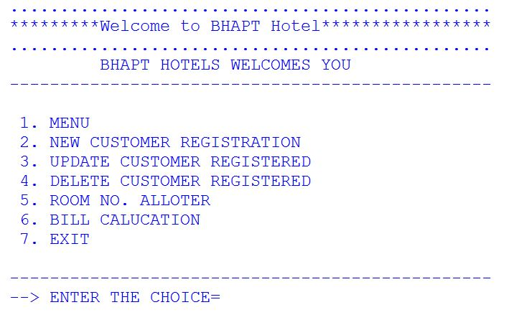

* NEW CUSTOMER REGISTRATION

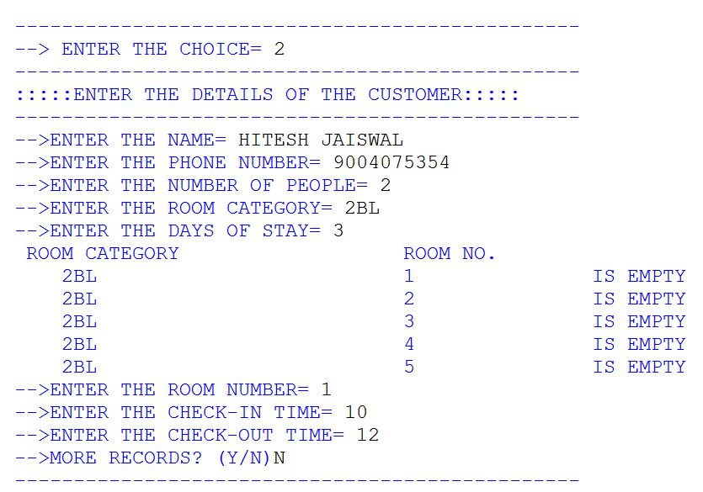

* MAIN MENU SCREEN:

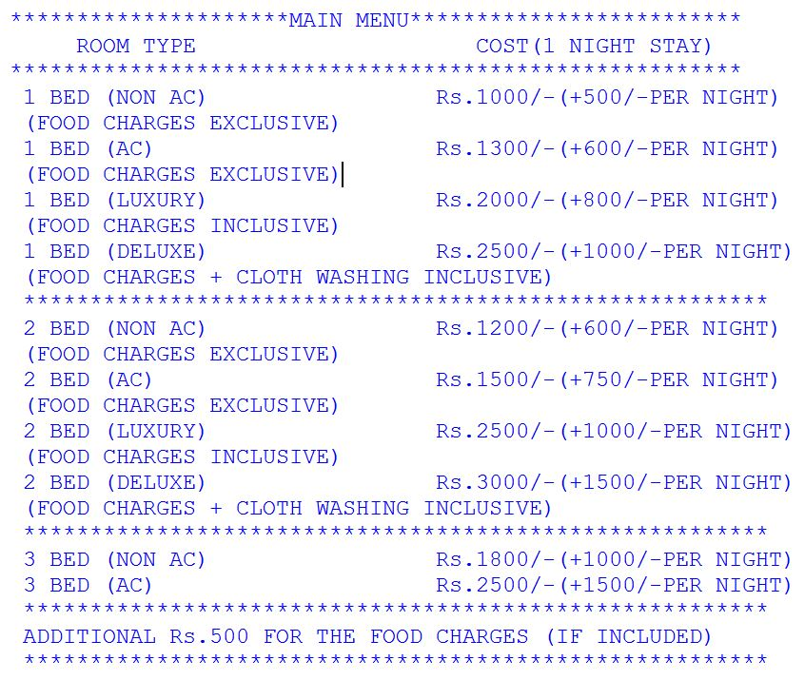

* DELETE FUNCTION:

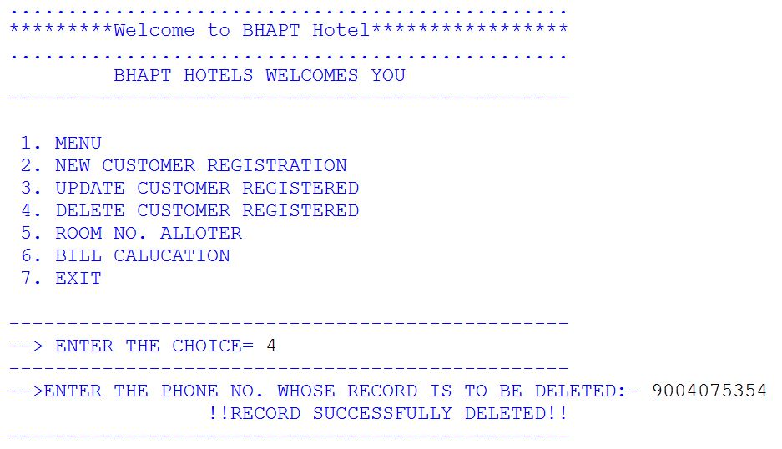

* UPDATE FUNCTION:

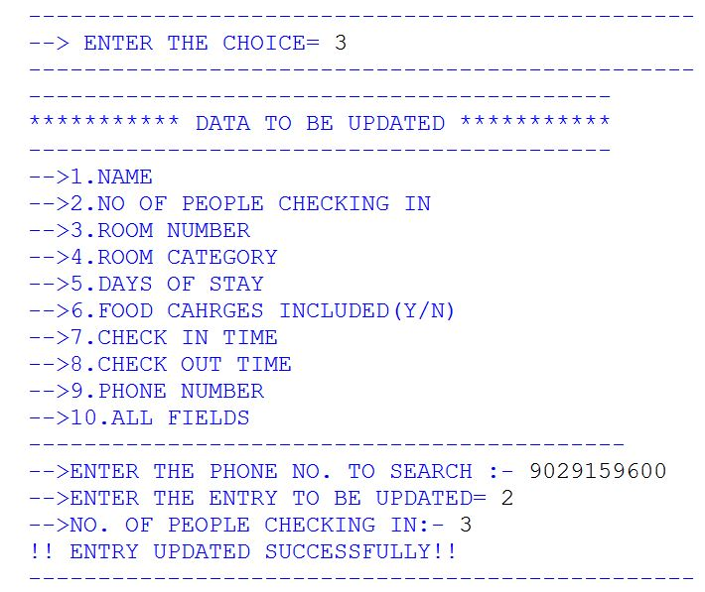

* ROOM AVAILABILITY FUNCTION:

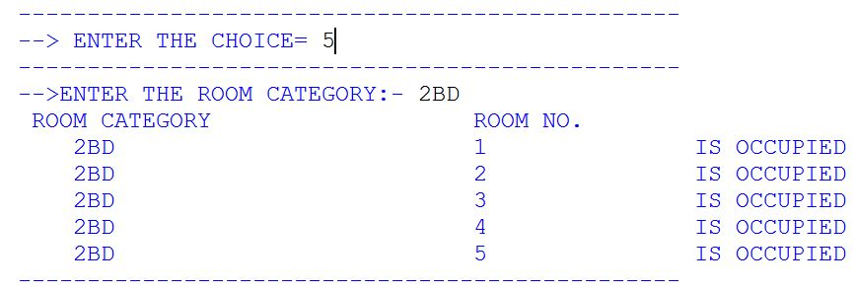

* BILL PAYEMENT FUNCTION:

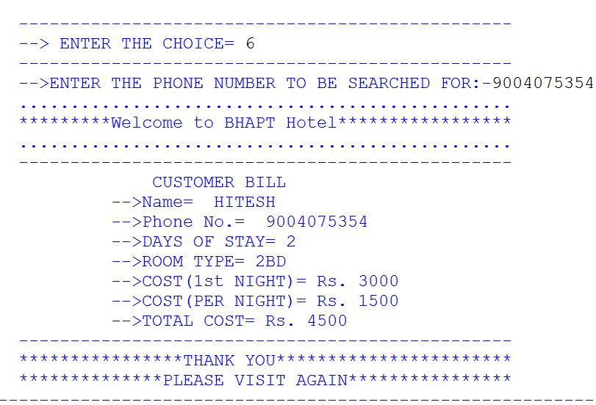

*BIBLIOGRAPHY*

* PROGRAMS GIVEN IN CLASS
* SOME INFORMATION FROM GOOGLE
* REST DONE BY OURSELVES